**IOT-PHASE 4**

**SMART WATER SYSTEM MANAGEMENT**

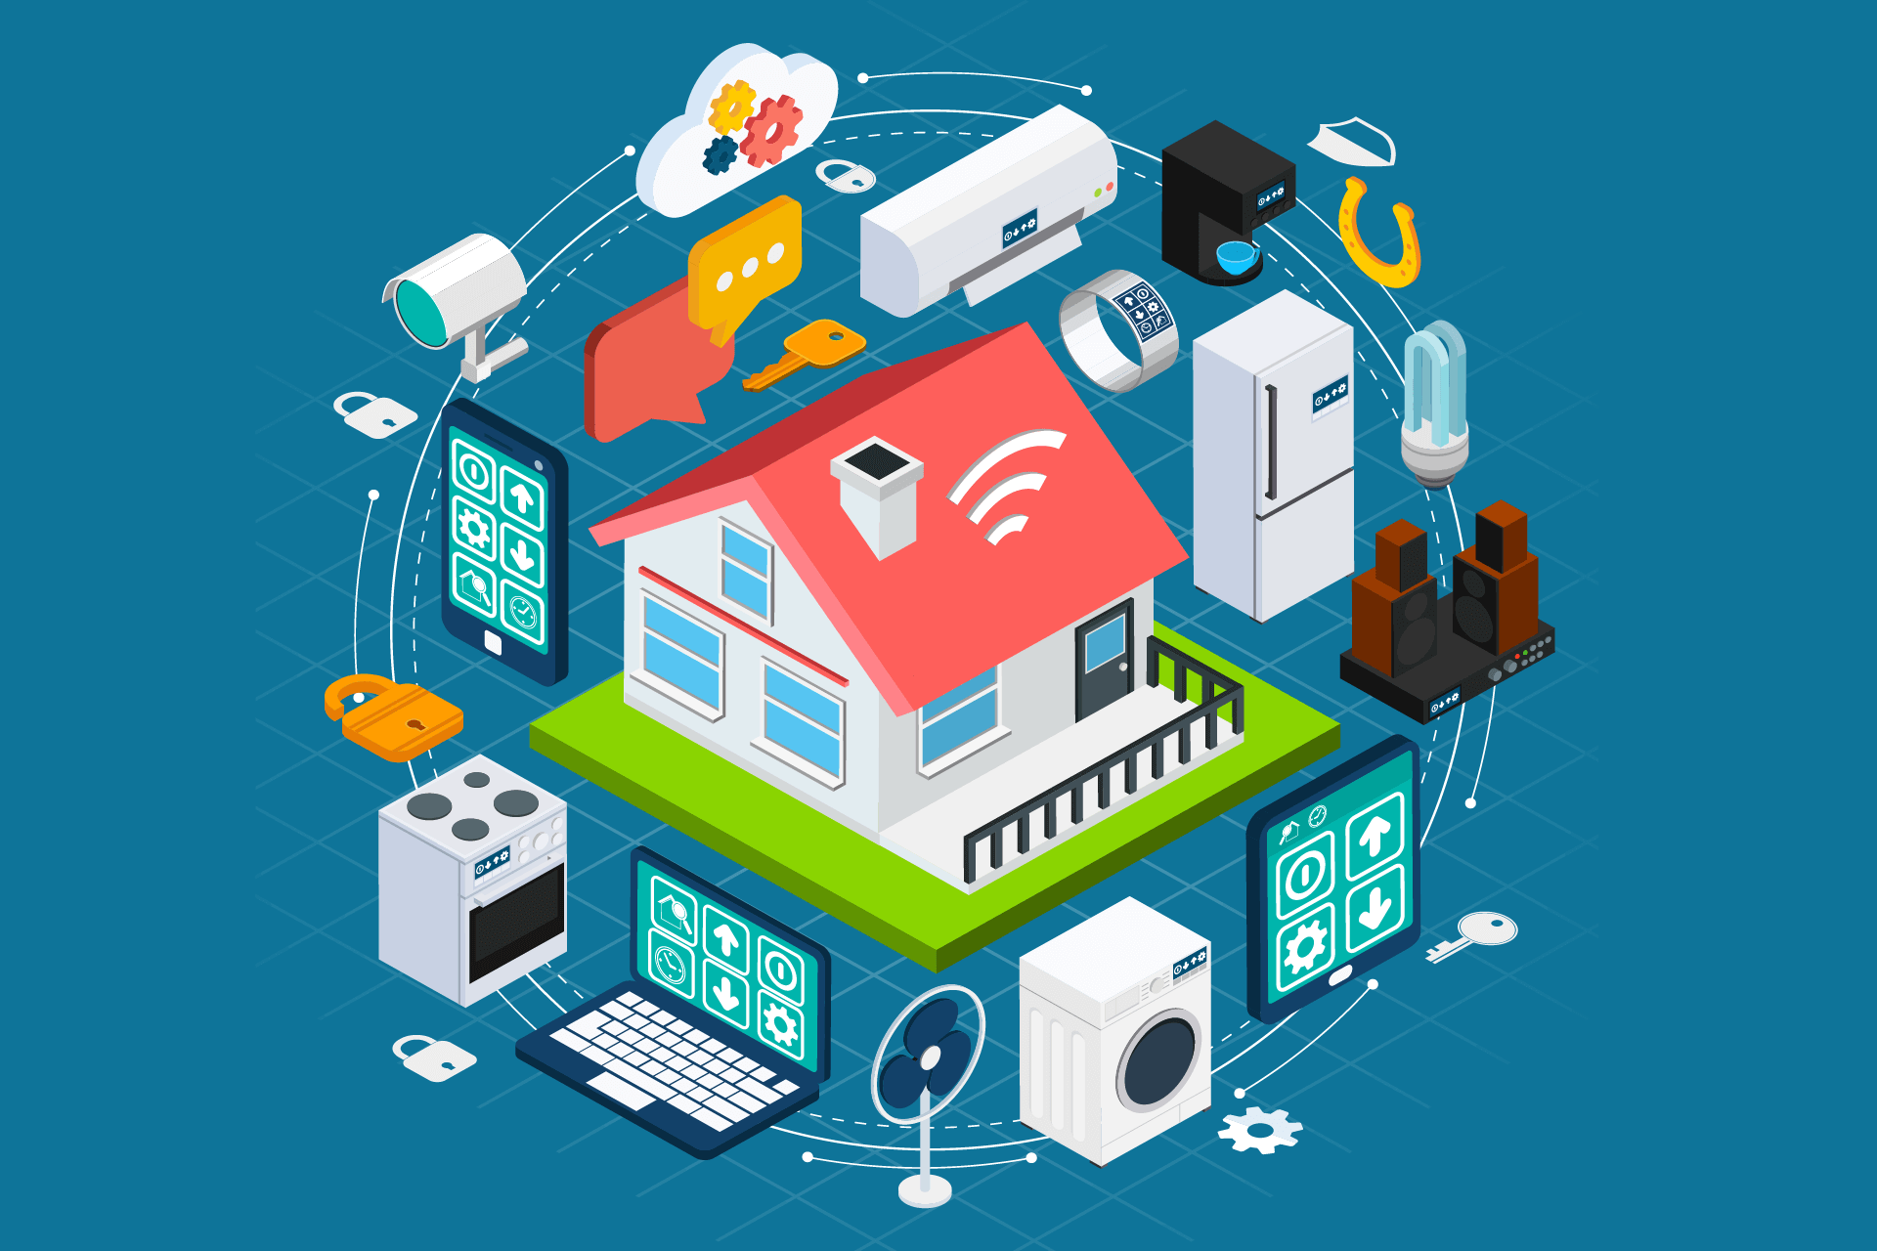

# **INTODUCTION:**

A smart water system is an integrated platform that makes use of cutting-edge technologies and data-driven solutions to manage many aspects of water resources in an efficient and effective manner. These systems are intended to decrease waste and improve general management procedures in addition to enhancing the sustainability, quality, and availability of water. An overview of the main components of a platform for smart water systems is provided below



# **PLATFORM DEVELOPMENT:**

## WHAT DOES THE PLATFORM DO?

1. Monitoring and Data Collection:

A network of sensors and data gathering tools is used by smart water systems to keep an eye on a variety of water resource-related metrics. This covers measures of temperature, flow rates, water level, water quality, and more. These sensors can be installed in a variety of places, including residences, businesses, treatment plants, distribution networks, and reservoirs.

1. Data Analysis and Management:

To handle the enormous volume of data gathered, the platform makes use of advanced data analytics techniques. The examination of this data offers insightful information about the state of the water and usage trends. The availability and demand for water may be forecasted and optimized using machine learning techniques.

3. Real-time Alerts and Notifications:

In the event of leaks, abnormalities in the water quality, or any other concern, the platform may notify and warn water utility operators and customers, guaranteeing prompt action and mitigation.

1. User Interface and Accessibility:

Decision-makers, water utility staff, and customers can all readily access and understand data thanks to user-friendly interfaces and mobile applications.

1. Demand Forecasting:

Smart water systems can forecast patterns in water demand by examining historical data and current information. This makes it possible for utilities to allocate resources more effectively and to guarantee a steady supply of water.

## TECHNOLOGIES USED:

The following technologies used in this project are web based platforms of

1. HTML , CSS
2. MIT APP INVENTOR

## WEB PLATFORM:

Because HTML and CSS are primarily used for structuring and styling web pages, respectively, it is not possible to create a complete smart water monitoring system using just these two languages. Additional technologies, such as JavaScript for functionality and data communication, as well as a backend server to handle data from sensors, are required to create a smart water monitoring system. However, I can provide you with a simple HTML and CSS template for a water monitoring system's user interface. Here's a demo of the following project with source code

### SOURCE CODE:

<!DOCTYPE *html*>

<html>

  <head>

    <title>Smart Water Monitoring System</title>

    <img *src*="../../images/images.jpeg" *alternate*=" picture" />

    <link *rel*="stylesheet" *type*="text/css" *href*="../IoT Project/style.css" />

  </head>

  <body>

    <header>

      <h1>Water Monitoring Dashboard</h1>

    </header>

    <section *class*="sensor">

      <h2>Water Level</h2>

      <div *class*="sensor-value">75%</div>

    </section>

    <section *class*="sensor">

      <h2>Water Purity</h2>

      <div *class*="sensor-value">92%</div>

    </section>

    <section *class*="sensor">

      <h2>Water Temperature</h2>

      <div *class*="sensor-value">28°C</div>

    </section>

  </body>

</html>

CSS CODE:

body {

  font-family: Arial, sans-serif;

  margin: *0*;

  padding: *0*;

  background-color: #f0f0f0;

}

header {

  background-color: #333;

  color: #fff;

  text-align: center;

  padding: *20px*;

}

.sensor {

  background-color: #fff;

  border: *1px* solid #ccc;

  margin: *20px*;

  padding: *20px*;

  border-radius: *5px*;

  box-shadow: *0* *0* *5px* #ccc;

}

.sensor h2 {

  font-size: *24px*;

  margin: *0*;

}

.sensor-value {

  font-size: *36px*;

  margin: *10px* *0*;

}

## OUTPUT:

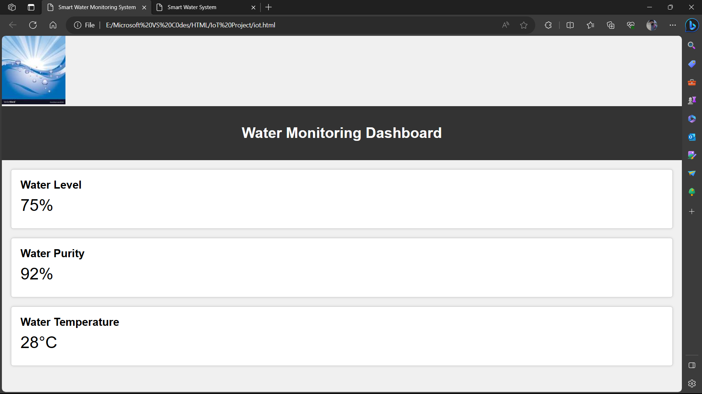

## **MIT APP INVENTOR:**

MIT App Inventor is primarily intended for developing mobile applications for Android devices, and it may not be appropriate for creating a full water monitoring system. However, you can create a simple mobile app that interacts with external sensors or data sources to display water monitoring information.

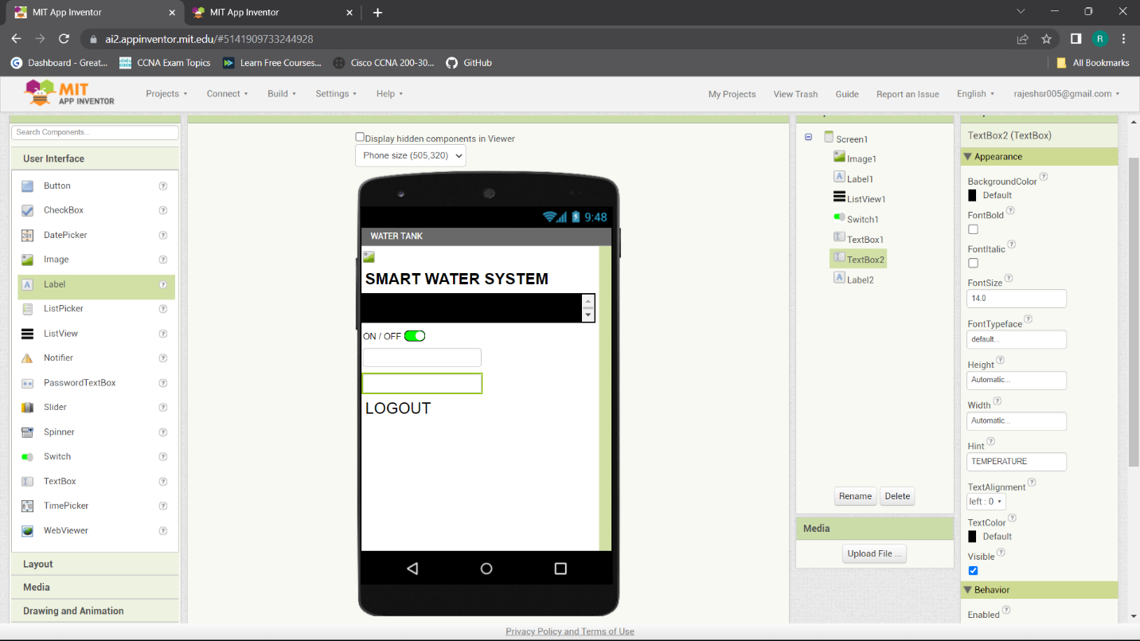

### WATER LEVEL SENSOR MEASUREMENT:

## **CONCLUSION:**

Smart water systems are an important step toward more efficient and sustainable water resource management. They play an important role in addressing water-related challenges such as water scarcity, infrastructure maintenance, and environmental protection, all while improving people's and communities' quality of life. As technology advances, these systems' capabilities will only become more sophisticated, making them an essential part of modern water management.